**Abstract**

This project consists of a many installed roles and features on a Windows server 2019 virtual machine running on a computer. The computer is connected to the router using a RJ45 or Ethernet cable, it also connects to a printer wirelessly.

The primary goal of this project was to create a virtualize large network attainable for a large company called Dunder Mifflin with nearly 120 users and to use basic physical devices like printer, router, and ethernet cables. The idea of Dunder Mifflin paper company was from a comedy TV show called “The Office” and it introduced characters like Michael Scott, Dwight Shrute, Jim Halpert, Pam Beesly and more.

**Concept and Theory**

The first main step of creating a network was importing a windows server 2019 iso virtual box and then installed Active Directory Domain Services.

I initially started with by creating 2 admins and 15 main characters from Dunder Mifflin paper company in the Active Directory Users and Computers then created 8 OU’s under the DM_OU. The OU’s are short for Organizational Units which stores user accounts, service accounts and/or computer accounts.

Each OU is part of 2 security groups (domain local and global) in a hierarchical structure

I visit ADManager Plus website to import 100 users into active directory

The company will need shared folders to share files to each other and it will also need different folders with their own permissions, to make sure other staff doesn’t have access.

This idea was from one of the previous labs in the CTEC1436 course

Added a Lexmark printer to the Windows Server 2019 and set some GPO permissions to allow Dunder Mifflin to print documents

Dunder Mifflin will also need a software deploy like OpenOffice, Office 365, LibreOffice and more.

Every business needs backups and I have chosen ADManager to backup the OU’s, users, installed roles, etc.

You can delete users and it can restore the user back to its place

Installed a Web Server (IIS) role and I can place icon on every user using GPO’s

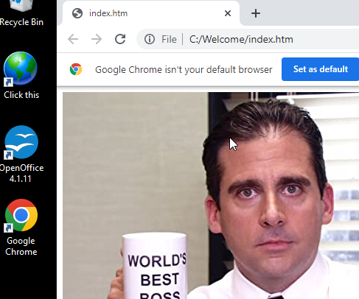

I set to static ip address to be able to ping the other virtual machines, then I installed DNS and DHCP server

Created a new scope which only allows certain ip addresses to be assigned and also exclude ip addresses

As you can see its working

To set all users restricting to use certain settings like control panel or change wallpaper or make sure a 45 minute lockout happens when the user enter their credentials 10 times, I will use GPO

**Performance Tests**

**Conclusions**

The project was nearly successful but not quite

Several important lessons learned:

1. When installing a software or role, that seems to be malicious, or you decided to change your mind on uninstalling the software or role but it doesn’t seem to go away, I used snapshots which can preserve the state and data of a virtual machine at a specific point in time, in another words it can act like a backup and restore which I found very useful installing certain software or roles.
2. i

**Limitations of the System**

**Suggestions**

**Appendices**